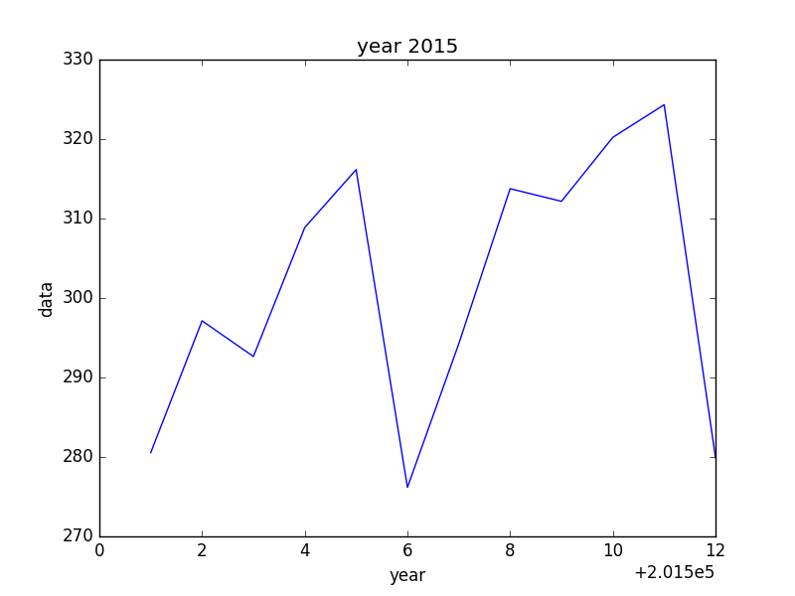

201501: 280.535741222

201502: 297.125552101

201503: 292.642789108

201504: 308.863964526

201505: 316.150934746

201506: 276.170014415

201507: 294.244397834

201508: 313.75617244

201509: 312.164223568

201510: 320.216716155

201511: 324.318952813

201512: 279.918411946

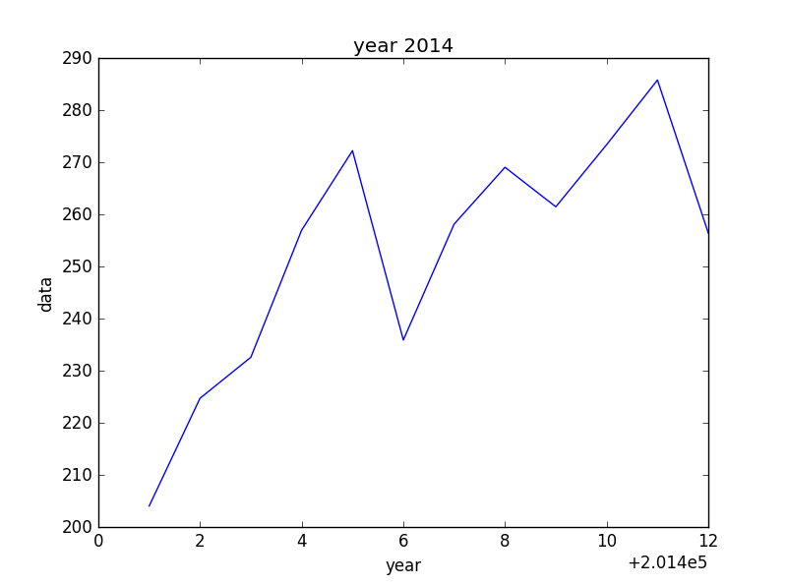

201401: 204.107821227

201402: 224.777603977

201403: 232.64450185

201404: 257.046724216

201405: 272.28342371

201406: 235.959388234

201407: 258.207057849

201408: 269.101446675

201409: 261.521651978

201410: 273.446645677

201411: 285.844660676

201412: 256.483017473